**Selected Administrative process: Renewal of a driving license (all categories)**

<https://en.mitos.gov.gr/index.php/%CE%94%CE%94:Renewal_of_a_driving_licence_(all_categories)>

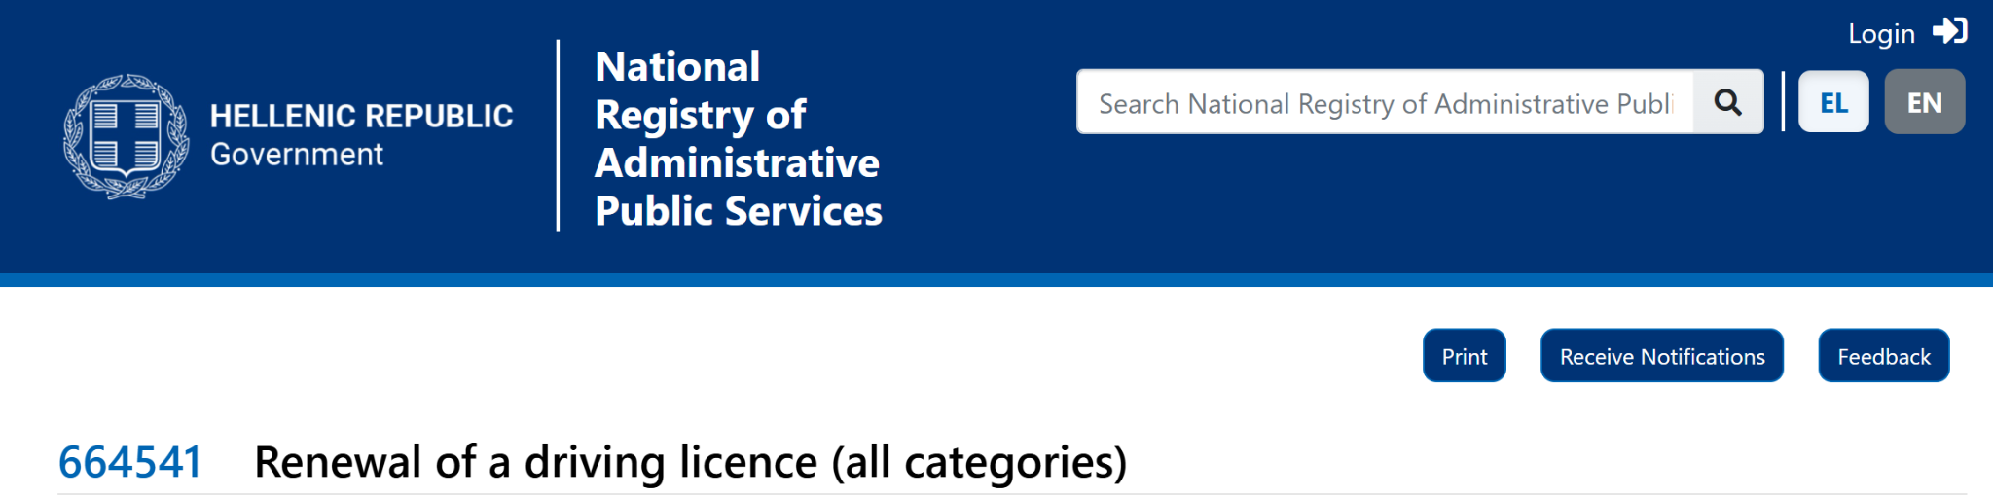

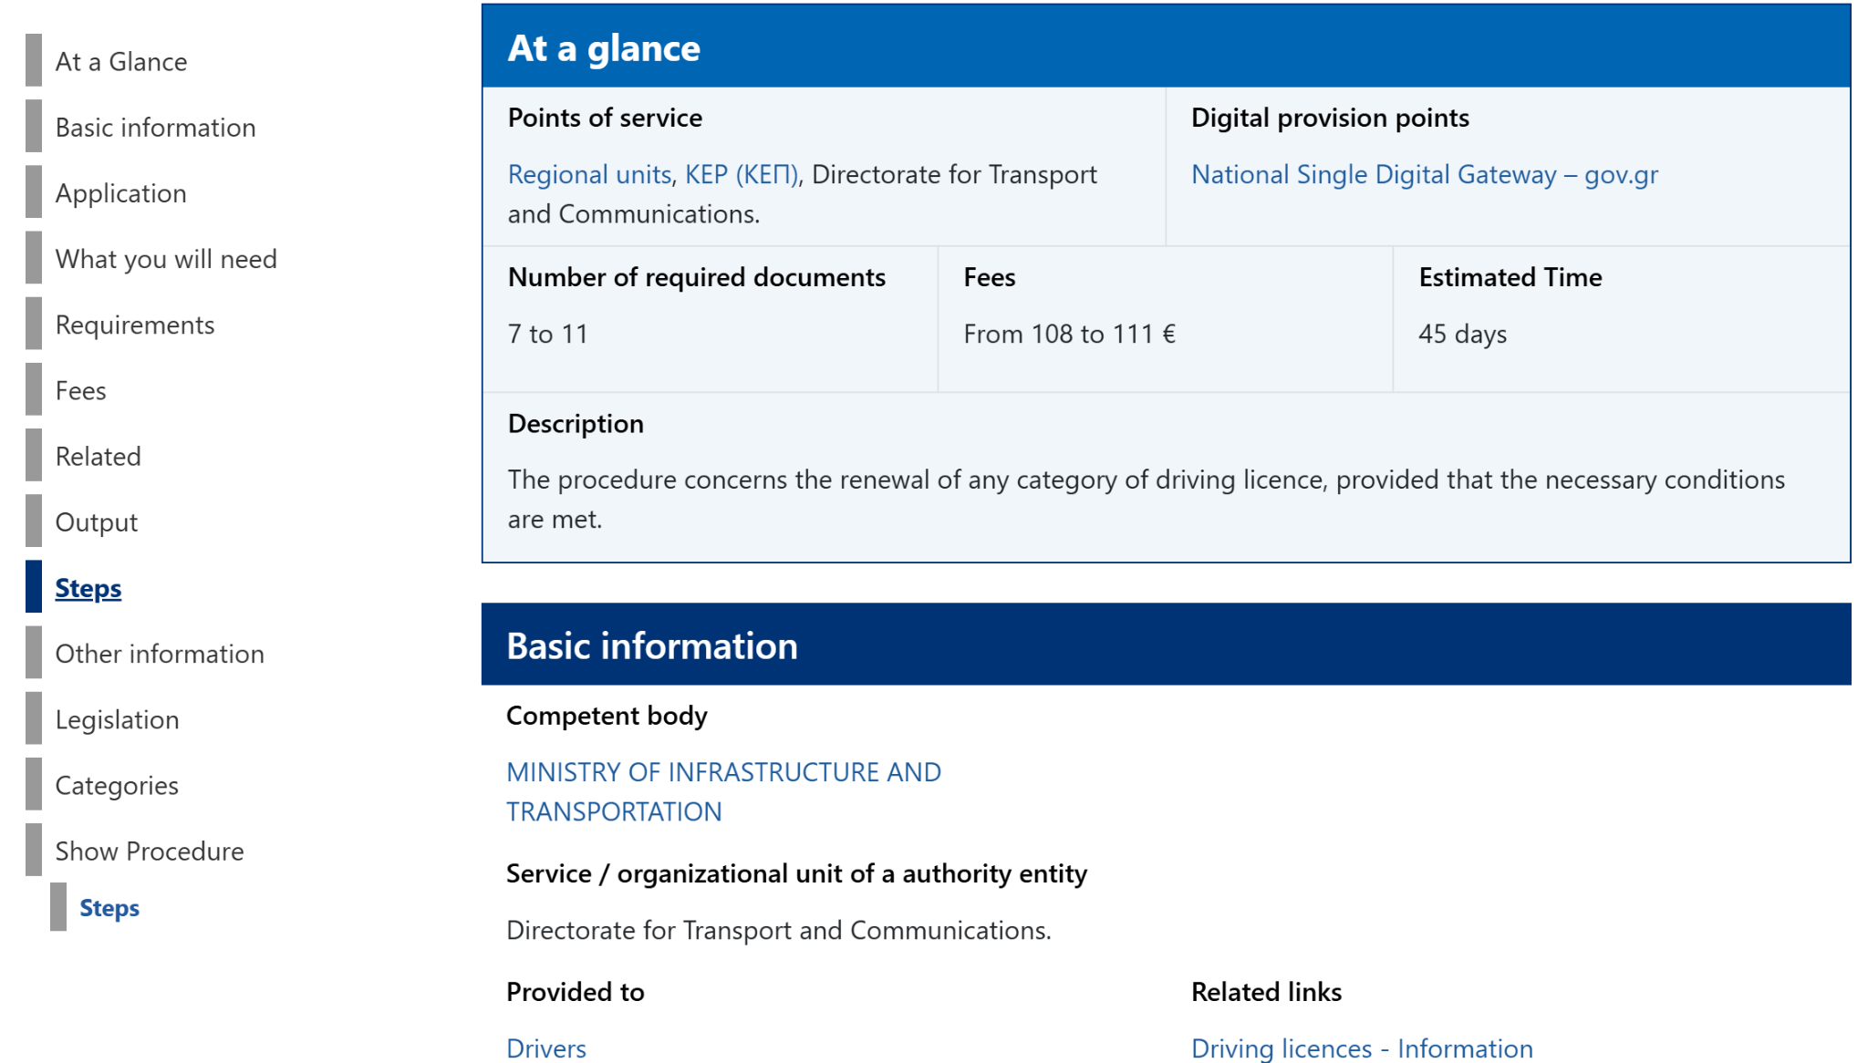

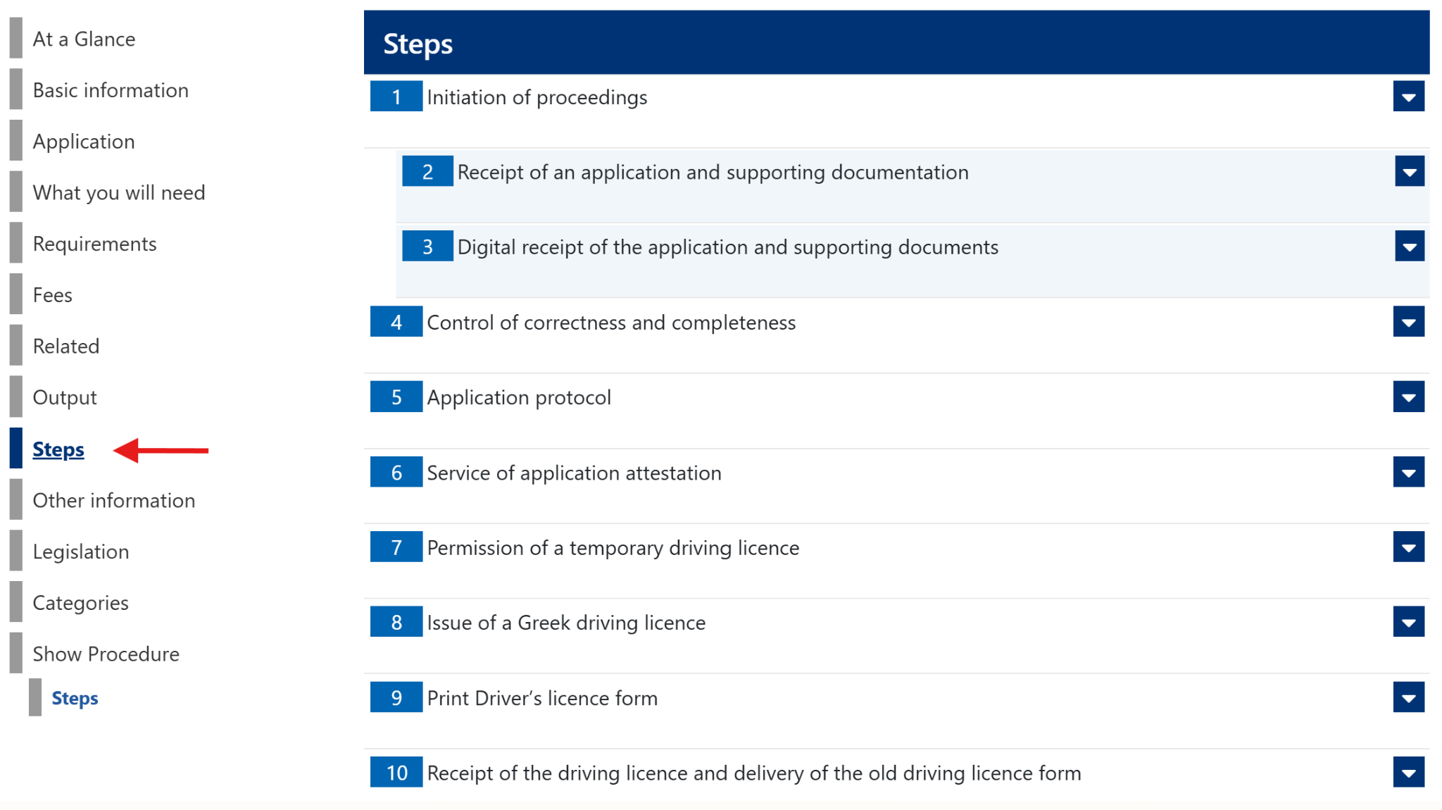

**Extension of the original process flow:**

To enable a more comprehensive evaluation of the tools' ability to model complex process flow, the authors extended the originally documented process by incorporating additional logic. As prior research has primarily evaluated LLMs’ performance in modeling business processes using fundamental elements - such as start and end events, activities, exclusive and parallel gateways - the authors introduce more complex logic in the original process flow that could be modeled with more advanced BPMN elements such as an event-based gateway (for point 1 below) and a boundary non-interrupting timer event (for point 2 below).

1) According to the documented process, in Step 4, the Transport and Communications Service (TCS) official is responsible for checking the completeness and correctness of the submitted documents. If any omissions are identified, the applicant is notified of the need to provide the missing documents.

At this point, the following logic was introduced:

*The process waits for one of two events to occur:  
   – The applicant submits the missing documents, or  
   – 15 days pass without submission.  
If no documents are submitted within 15 days, the process is terminated.*

2) Additionally, in Step 8 of the documented process, the TCS official issues the driving license by making an electronic entry in the Driving License Register.

At this point, the authors introduced the following logic:

*As long as the license remains unissued, an automated reminder is sent to the responsible official every 5 working days.*